

**“AZƏRBAYCAN HAVA YOLLARI” CJSC NATIONAL AVIATION ACADEMY**

**Individual Work № 4:**

**Topic:Lists. Heaps.With examples in Python programming language**

**Subject: Obyektyönümlü proqramlaşdırma**

**Teacher: Mehemmed Shahmaliyev**

**Group: 1459i Student: Hesenova Firuze**

**Date: Signature:H.F**

**Baku 2022**

## What is Heap?

Heap is a data structure that follows a complete binary tree's property and satisfies the heap property. Therefore, it is also known as a binary heap. As we all know, the complete binary tree is a tree with every level filled and all the nodes are as far left as possible. In the binary tree, it is possible that the last level is empty and not filled. Now, you must be wondering what is the heap property? In the heap data structure, we assign key-value or weight to every node of the tree. Now, the root node key value is compared with the children’s nodes and then the tree is arranged accordingly into two categories i.e., max-heap and min-heap. Heap data structure is basically used as a heapsort algorithm to sort the elements in an array or a list. Heapsort algorithms can be used in priority queues, order statistics, Prim's algorithm or [Dijkstra's algorithm](https://favtutor.com/blogs/dijkstras-algorithm-cpp" \t "https://favtutor.com/blogs/_blank), etc. In short, the heap data structure is used when it is important to repeatedly remove the objects with the highest or the lowest priority.

As learned earlier, there are two categories of heap data structure i.e. max-heap and min-heap. Let us understand them below but before that, we will study the heapify property to understand max-heap and min-heap.

## What is Heapify?

Before moving forward with any concept, we need to learn what is heapify. So, the process of creating a heap data structure using the binary tree is called Heapify. The heapify process is used to create the Max-Heap or the Min-Heap. Let us study the Heapify using an example below:

**Consider the input array as shown in the figure below:**

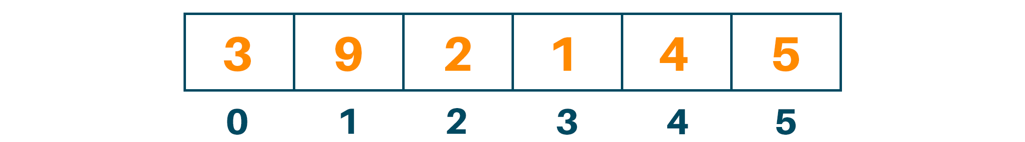

**Using this array, we will create the complete binary tree**

**We will start the process of heapify fr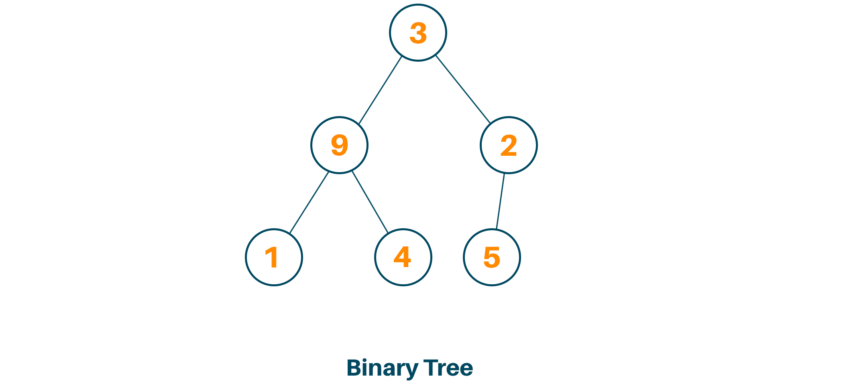om the first index of the non-leaf node as shown below:**

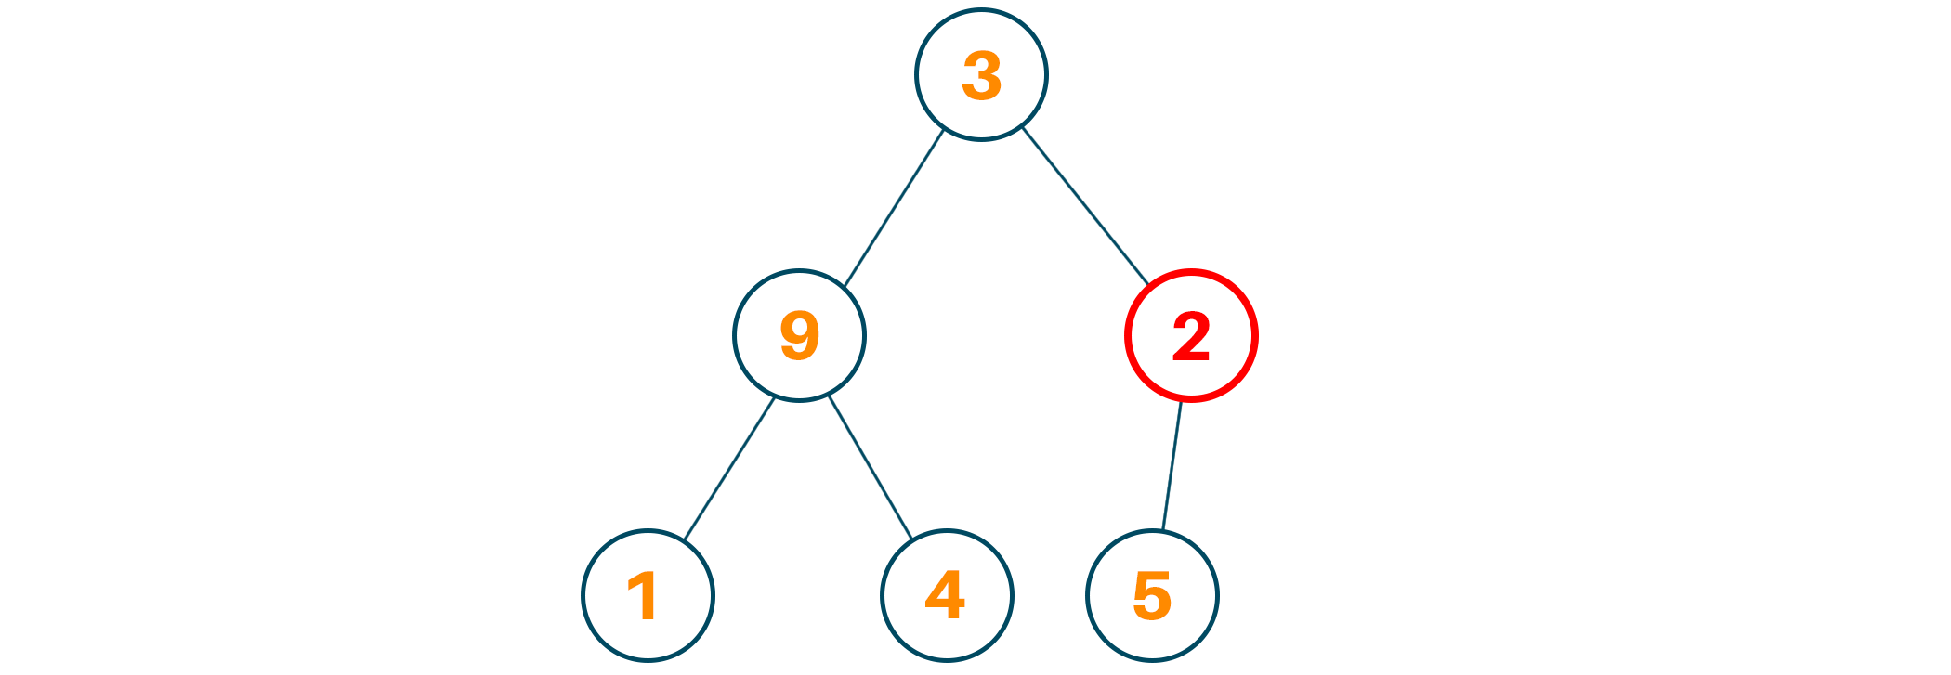

Now we will set the current element “k” as “largest” and as we know the index of a left child is given by “2k + 1” and the right child is given by “2k + 2”.

Therefore, if the left child is larger than the current element i.e. kth index we will set the “largest” with the left child’s index and if the right child is larger than the current element i.e., kth index then we will set the “largest” with right child’s index.

Lastly, we will swap the “largest” element with the current element(kth element).

**We’ll repeat the above steps 3-6 until the tree is heaped.**

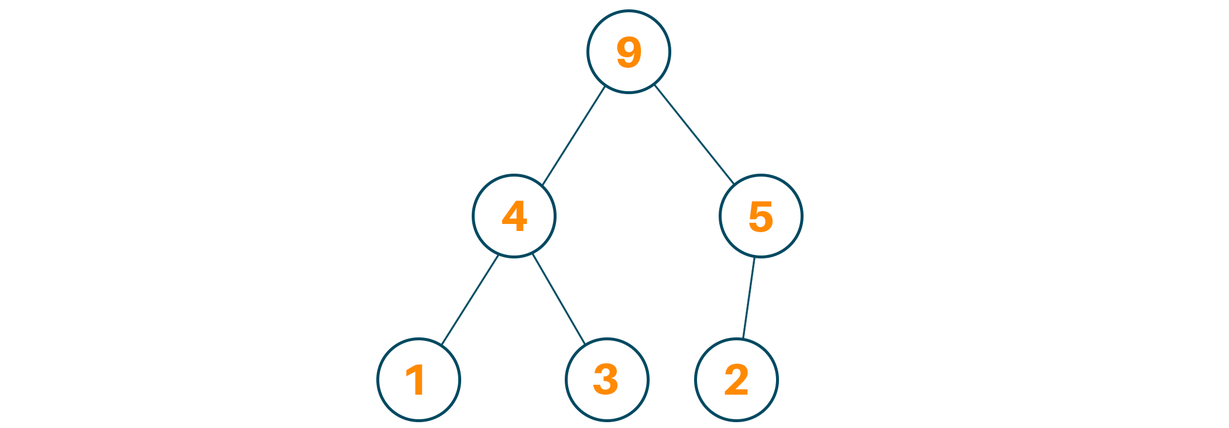

### Algorithm for Max-Heapify

*maxHeapify(array, size, k)*

*set k* ***as*** *largest*

*leftChild =* ***2k*** *+* ***1***

*rightChild =* ***2k*** *+* ***2***

***if*** *leftChild > array[largest]*

*set leftChildIndex* ***as*** *largest*

***if*** *rightChild > array[largest]*

*set rightChildIndex* ***as*** *largest*

*swap array[k]* ***and*** *array[largest]*

## 

### Algorithm for Min-Heapify

*minHeapify(array, size, k)*

*set k* ***as*** *smallest*

*leftChild =* ***2k*** *+* ***1***

*rightChild =* ***2k*** *+* ***2***

***if*** *leftChild < array[smallest]*

*set leftChildIndex* ***as*** *smallest*

***if*** *rightChild < array[smallest]*

*set rightChildIndex* ***as*** *smallest*

*swap array[k]* ***and*** *array[smallest]*

## 

## What is Max Heap?

When the value of each internal node is larger than or equal to the value of its children node then it is called the Max-Heap Property. Also, in a max-heap, the value of the root node is largest among all the other nodes of the tree. Therefore, if “a” has a child node “b” then

Key(a) >= key(b)

represents the Max-Heap Property. Let us display the max-heap using an array. Therefore, the root node will be arr[0]. So, for kth node i.e., arr[k]:

arr[(k - 1)/2] will return the parent node

arr[(2*k) + 1] will return left child

arr[(2*k) + 2] will return right child

### Algorithm for Max Heap

MaxHeap(array, size)

loop **from** **the** **first** **index** down to zero

call maxHeapify

## 

### Algorithm for Insertion in Max Heap

If there **is** no node,

create a new Node.**else** (a node **is** already present)

insert the new Node at the end

maxHeapify the array

## 

### Algorithm for Deletion in Max Heap

If nodeDeleted **is** the leaf Node

remove the node

Else swap nodeDeleted **with** the lastNode

remove nodeDeleted

maxHeapify the array

### Python Code for Max Heap Data Structure

***def******max_heapify****(A,k):*

*l = left(k)*

*r = right(k)*

***if*** *l < len(A)* ***and*** *A[l] > A[k]:*

*largest = l*

***else****:*

*largest = k*

***if*** *r < len(A)* ***and*** *A[r] > A[largest]:*

*largest = r*

***if*** *largest != k:*

*A[k], A[largest] = A[largest], A[k]*

*max_heapify(A, largest)*

***def******left****(k):*

***return******2*** *\* k +* ***1***

***def******right****(i):*

***return******2*** *\* k +* ***2***

***def******build_max_heap****(A):*

*n = int((len(A)//****2****)-****1****)*

***for*** *k* ***in*** *range(n, -****1****, -****1****):*

*max_heapify(A,k)*

*A = [****3****,****9****,****2****,****1****,****4****,****5****]*

*build_max_heap(A)****print****(A)*

### 

### Output

[9, 4, 5, 1, 3, 2]

## What is Min Heap?

When the value of each internal node is smaller than the value of its children node then it is called the Min-Heap Property. Also, in the min-heap, the value of the root node is the smallest among all the other nodes of the tree. Therefore, if “a” has a child node “b” then

Key(a) < key(b)

represents the Min Heap Property. Let us display the max heap using an array. Therefore, the root node will be arr[0]. So, for kth node i.e., arr[k]:

arr[(k - 1)/2] will return the parent node

arr[(2*k) + 1] will return left child

arr[(2*k) + 2] will return right child

### Algorithm for Min Heap

MinHeap(array, size)

loop **from** **the** **first** **index** down to zero

call minHeapify

### Algorithm for Insertion in Min Heap

If there **is** no node,

create a new Node.**else** (a node **is** already present)

insert the new Node at the end

minHeapify the array

## 

### Algorithm for Deletion in Min Heap

If nodeDeleted **is** the leaf Node

remove the node

Else swap nodeDeleted **with** the lastNode

remove nodeDeleted

minHeapify the array

### Python Code for Min Heap Data Structure

***def******min_heapify****(A,k):*

*l = left(k)*

*r = right(k)*

***if*** *l < len(A)* ***and*** *A[l] < A[k]:*

*smallest = l*

***else****:*

*smallest = k*

***if*** *r < len(A)* ***and*** *A[r] < A[smallest]:*

*smallest = r*

***if*** *smallest != k:*

*A[k], A[smallest] = A[smallest], A[k]*

*min_heapify(A, smallest)*

***def******left****(k):*

***return******2*** *\* k +* ***1***

***def******right****(k):*

***return******2*** *\* k +* ***2***

***def******build_min_heap****(A):*

*n = int((len(A)//****2****)-****1****)*

***for*** *k* ***in*** *range(n, -****1****, -****1****):*

*min_heapify(A,k)*

*A = [****3****,****9****,****2****,****1****,****4****,****5****]*

*build_min_heap(A)****print****(A)*

### 

### Output

[1, 3, 2, 9, 4, 5]

## Min Heap vs Max Heap

|  |  |
| --- | --- |
| **Min Heap** | **Max Heap** |
| The key at the root node is smaller than or equal to the key of their children node | The key at the root node is larger than or equal to the key of their children node |
| The minimum key element is the root node | The maximum key element is the root node |
| Uses the ascending priority | Uses the descending priority |
| The smallest element has priority while construction of min-heap | The largest element has priority while construction of max-heap |
| The smallest elements are popped out of the heap | The largest element is popped out of the heap |

## Time complexity

The running time complexity of the building heap is O(n log(n)) where each call for heapify costs O(log(n)) and the cost of building heap is O(n). Therefore, the overall time complexity will be O(n log(n)).

## Applications of Heap

* Heap is used while implementing priority queue
* Heap is used in Heap sort
* Heap data structure is used while working with Dijkstra's algorithm
* We can use max-heap and min-heap in the operating system for the job scheduling algorithm
* It is used in the selection algorithm
* Heap data structure is used in graph algorithms like prim’s algorithm
* It is used in order statistics
* Heap data structure is used in k-way merge

## Conclusion

Heap data structure is a very useful data structure when it comes to working with graphs or trees. Heap data structure helps us improve the efficiency of various programs and problem statements. We can use min-heap and max-heap as they are efficient when processing data sets. As you get a good command of heap data structure, you are great to work with graphs and trees at the advanced level.